Robert Observations About DegreeWorks

November 3, 2015

When there is a problem with courses counting toward a degree, it is Tampa who must resolve the problem in DegreeWorks…

Where do I look to get classes that needed to take, versus classes already taken….

For Robert, now he knows that that classes in the green are classes he has already taken, but the ones in pink are ones he still needs. The interface appears confusing. For example, Robert has completed 4174, but it shows up in two places. See below

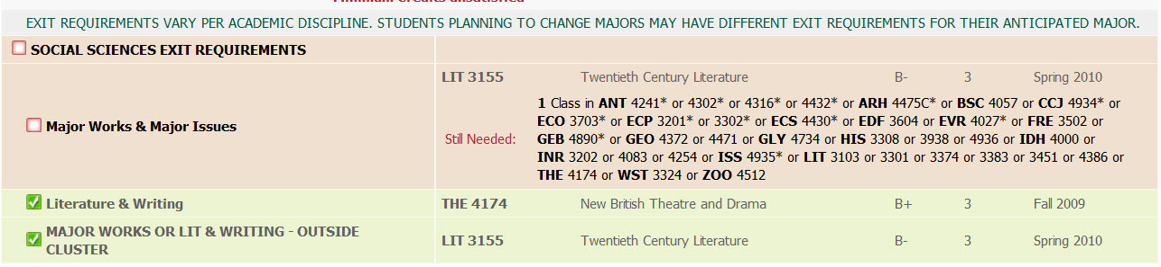

Does not show substitutions….for example,he needs to take one more culture class to satisfy his language requirement, but the problem is that it only shows language courses as an option to satisfy the degree. See below snapshot.

